|  |  |
| --- | --- |
|  | MGM Grand: Customer segmentation |
|  |  |
| 6/25/2017 | Marketing and CRM – Group Assignment |
|  | **Group 1**  Suryaprakash Gaddam  Praveen Kumar T V  Raghu Anjan  Shashank Kandala  Santhosh Murali |

Contents

Discussion and understanding of case 2

Approach 3

Weightage 3

Recency 3

Frequency 3

Monetary 3

Assumption 4

Data Preparation 4

Insights and Observations 4

Segment Classification 4

Observations 5

Heat Map 5

Number of Customers, Segment wise 5

Earnings per Customer 5

Summary 7

R Program to Score RFM 8

MGM Grand: Customer segmentation

# **Discussion and understanding of case**

MGM Grand Hotel, which is part of MGM Grand Resorts Group and that is Part of MGM Mirage has its strong roots in Las Vegas when it comes to Casinos and other Leisure activities. (Case document is dated Sep-12,2006, business model of MGM Grand’s activities is solely based on Case Document and it might not reflect current business scenario). MGM Grand Hotel was performing very well when it comes to Casino or other gaming activities. It also leads the trend by using Non-gaming entertainment as an hook to pull crowd to casinos and lodging hotels for them to stay and play. To boost the profit in Casinos, MGM Grand uses something called Comps (Complementary or a gift) for the gamers who spends enough or prospective spenders in the form of discounts in lodging, food, entertainment or beverages etc., MGM Grand hotel as observed a surge in revenue from this non-gaming entities (shows, hotels, restaurants, and spas) and believes that profit opportunity is not exploited in non-gaming leisure and entertainment business. if it can find answer to “how non-gaming leisure and entertainment business could be exploited independently and profitably?”, it can make strategic move to enjoy more profit out of it. There are several questions needs to be answered before that,

1. Are we capturing all the data from non-gaming customers? If not, How the non-gaming customer profitability could be better captured.
2. How much of profitability in non-gaming sectors was driven by gamblers, and their families, by non-gaming customer segment.
3. Non-gaming activities at the MGM Grad were highly profitable enterprises, Customers were not fully understood. Not better segmentation of Customers in Non-Gaming activities. How can we segment non-gaming customers?
4. Could the Comps provided to Gaming customers to improve profitability could be applied to non-gaming customers.

The answers for all the above questions can be found if we can do the following

* Creating customer segments based on profitability by adding up earnings from casino and hotel stay.
* Customer segment wise, calculate proportion of earnings from hotel stay as a % over total earnings (casino + hotel) and identify target segments and way to improve earnings for Hotel.

And, this will help MGM to not only identify the opportunities, but, also identify target segments and also ways in which it add them to their Customer List.

## Approach

To Segment the customer and break the profits in segments, we can use RFM Technique.

# Weightage

Using RFM Technique we can segment the customers based on Recency, Frequency and Monetary. Number of Segments is subjective and based on the business problem. Here, assigning weightage preference was given to recent transactions and visits over very old transactions. We believe that customer who visited recently has more probability of visiting again., esp. for leisure and entertainment activities. It might not be ideal, but for this study we took this approach.

### Recency

|  |  |
| --- | --- |
| Condition | Weightage |
| When Last transaction is after 17-Sep-2004 | 5 |
| Transaction between 24-Dec-2003 to 16-Sep-2004 | 4 |
| Transaction between 03-Oct-2002 to 23-Dec-2003 | 3 |
| Transaction between 08-Jun-2002 to 02-Oct-2002 | 2 |
| Transaction between 01-Jan-2002 to 07-Jun-2002 | 1 |

### Frequency

|  |  |
| --- | --- |
| Condition | Weightage |
| More than 10 Transactions | 5 |
| Between 5 and 9 Transactions | 4 |
| Between 3 and 4 Transactions | 3 |
| Only 2 Transactions | 2 |
| Only 1 Transaction | 1 |

### Monetary

|  |  |
| --- | --- |
| Condition | Weightage |
| Roughly More than $153 | 5 |
| Roughly Between $71 and $152.99 | 4 |
| Roughly Between $35 and $70.99 | 3 |
| Roughly Between $13 and $34.99 | 2 |
| Roughly Up to $12.99 | 1 |

# Assumption

Customer visiting to any of the hotels provided below as revisit as everything sums up to MGM Grand Resorts.

1. The Mirage
2. Treasure Island
3. MGM Grand Las Vegas
4. New York-New York
5. MGM Grand Detroit
6. Bellagio
7. Beau Rivage.

# Data Preparation

1. Removed all lines without “Player ID” from Casino and Hotel data.
2. Net earnings for the casino are calculated as “Total Theo” less “Comp”.
3. Calculated individual earnings from “Room”, “Others”, “FNB” – Food & Beverages, “Entertainment” and “Retail”, using the formula Debit-Credit
4. Used Profit % given in the question to arrive at individual Profit Share.
5. Calculated Total Earnings using individual earnings.

# Insights and Observations

## Segment Classification

|  |  |
| --- | --- |
| **Pawns** | These are the customers who visited long back and with maximum of 4 visits and revenue is not more than $70 including all. |
| **Jacks** | Visiting once or twice and rarely thrice. Mostly last visited was before 3 years and negligibly few in recent times. On an Average giving Revenue $70 and $150 |
| **Queens** | Mostly visited before 1 or 2 years, usually visiting 3 to 9 times and spending averagely between $34 and $150 |
| **Kings** | These are all the people who visited in last 1 ½ years, visiting more than 10 times or 20 averagely and spending $450 roughly |
| **Aces** | These are the customers who visited in recent months, and visiting averagely 40 times, astonishing! And spending $1700 roughly! |

## Observations

### Heat Map

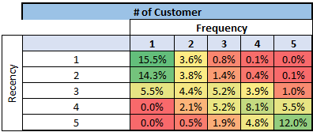

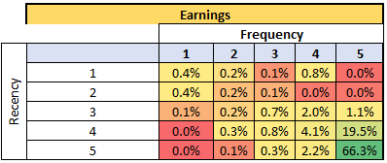

### Number of Customers, Segment wise

|  |  |  |  |  |  |  |
| --- | --- | --- | --- | --- | --- | --- |
| Business Unit | Pawns | Jacks | Queens | Kings | Aces | Grand Total |
| Casino | 809 | 910 | 1061 | 975 | 204 | 3959 |
| Hotel | 335 | 659 | 119 | 12 |  | 1125 |
| Hotel & Casino | 73 | 230 | 198 | 196 | 68 | 765 |
| Grand Total | **1217** | **1799** | **1378** | **1183** | **272** | **5849** |

**Net Earnings, Segment wise**

|  |  |  |  |  |  |  |
| --- | --- | --- | --- | --- | --- | --- |
| Business Unit | Pawns | Jacks | Queens | Kings | Aces | Grand Total |
| Casino | $(3,635) | $117,354 | $503,769 | $4,016,940 | $9,641,377 | $14,275,806 |
| Hotel | $10,542 | $64,570 | $26,566 | $6,710 |  | $108,388 |
| Hotel & Casino | $(9,104) | $58,668 | $88,124 | $3,297,553 | $3,736,011 | $7,171,253 |
| Grand Total | **$(2,197)** | **$240,592** | **$618,459** | **$7,321,204** | **$13,377,388** | **$21,555,447** |

### Earnings per Customer

|  |  |  |  |  |  |  |
| --- | --- | --- | --- | --- | --- | --- |
| Row Labels | Pawns | Jacks | Queens | Kings | Aces | Grand Total |
| Casino | $(4) | $129 | $475 | $4,120 | $47,262 | $3,606 |
| Hotel | $31 | $98 | $223 | $559 |  | $96 |
| Hotel & Casino | $(125) | $255 | $445 | $16,824 | $54,941 | $9,374 |
| Grand Total | **$(2)** | **$134** | **$449** | **$6,189** | **$49,182** | **$3,685** |

#### Views

1. ACES are not using any leisure or entertainment facilities, still, they are very profitable in Gaming business. Let’s not disturb that segment for now.
2. On contrary, “Pawns”, They are adding losses to the business, esp in Casino. But in Hotel they are giving considerable earnings. These people are basically tourists or one-time visitors, who come, stay and sometimes play in MGM Grand. As they are making us to incur negative earnings in Casino and Positive in Hotels, we can look at a option of offering something specific to boarding & lodging and less recommend offers for gaming. Probably Floor Hosts might be trained to handle these customers on Slots, and offer them to buy loyalty cards, that will boost their hotel stay.
3. Now narrowing down to other 3 prominent and challenging segments, “Jacks, Queens and Kings”. With specific to Hotels, our initial look at the net earnings table will give a perception that Jacks bring more revenue to MGM, than Queens and Kings. That is true. But, we also have to look at number of customers behind it. Kings and Queens bring more money to MGM individually, than Jacks.
   1. A “Queen” Customer brings 2.5 times more revenue than a Jack Customer
   2. A “King” Customer brings 5.5 times more revenue than a Jack Customer.
4. We may have to focus on offering “Premium and Privilege” Loyalty Membership Cards for King Customers and “Premium Cards” for Queen Customers, using that they can upgrade their stay in more luxurious rooms.
5. Few customers of King segment become eligible to Platinum+ Privileges, how? Some “King” Customers who lodge and also plays Casino is bringing 30 times more revenue than the King customers who Just Lodge. To attract these type of Customers, MGM can offer Free Slot Tokens or Lifetime Gaming Tokens as that will encourage Platinum+ King Customers to Stay and Play, adding more to MGM’s Top line.

#### Deep further.

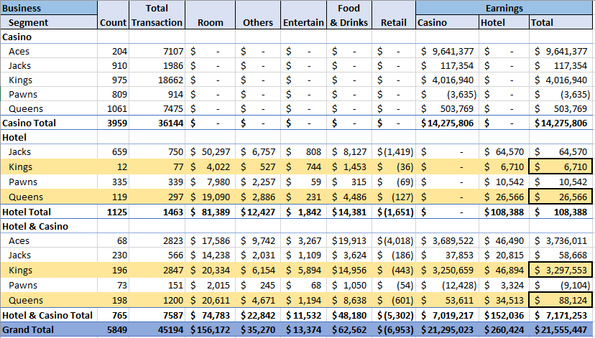

* If it is Just Hotel, Queen Customers bring more revenue (without considering the customer count).
* Look and Compare Total revenue between Kings and Queens for “Hotel and Casino” together. Given, the number of customers contributing for revenue are very close, “Kings” Bring 37 times more money than Queens. We can suggest MGM to give “Bundle offer” in that range so that we can attract more Kings.

#### What does Kings and Queens look Specifically for?

If it is going to be Queen and King, what Specific item in Leisure and Entertainment should MGM Focus on.

##### Earnings per Customer

##### 

# Summary

|  |  |
| --- | --- |
| **Pawns** | Roll-out promotion Specific to Leisure and Entertainment.  Train Floor Hosts in such a way to apply techniques to identify these customers in slot machine and minimize losses in MGM. |
| **Jacks** | Jacks will exist ever, we can continue to apply existing offers and Promotions to them. |
| **Queens** | Discounted Premium Loyalty Membership Cards for Their Stay across multiple Facilities across US and Also, once in a while upgrade their Room Standards. |
| **Kings** | Kings are 2 Types  **Premium and Privileged** –  Discounted Premium and Privilege Loyalty Membership Cards for Their Stay across multiple Facilities across US and Also, once in a while upgrade their Room Standards. Offer premium rows for Entertainment Events, as they like and spend for it more.  **Premium and Privileged with Platinum +**  There are High Revenue Generating Customers, who Stay and Play. In addition to the offers of “Premium and Privileged” customers, MGM can offer Free Slot Tokens or Lifetime Gaming Tokens. Personalized experience for them in Slots with Individual Attention from Floor Hosts. |
| **Aces** | Do not Disturb. |

# R Program to Score RFM

#Required Libraris

#library(didrooRFM)

#library(plyr)

getwd()

setwd(dir = "c:/___/")

casino <- read.csv("Casino.csv", stringsAsFactors = F)

hotel <- read.csv("Hotel.csv", stringsAsFactors = F)

casino_final <- casino[,c(1,4,17)]

names(casino_final)[1] <- 'CustomerID'

names(casino_final)[2] <- 'DateofPurch'

names(casino_final)[3] <- 'Amount'

casino_final$DateofPurch <- as.Date(casino_final$DateofPurch,"%d-%b-%y")

hotel_final <- hotel[,c(2,4,8)]

names(hotel_final)[1] <- 'CustomerID'

names(hotel_final)[2] <- 'DateofPurch'

names(hotel_final)[3] <- 'Amount'

hotel_final$DateofPurch <- as.Date(hotel_final$DateofPurch,"%d-%b-%Y")

mgm <- rbind(casino_final,hotel_final)

mgm$TransNo <- 1:nrow(mgm)

mgm_final <- subset(mgm, select=c(4,1:3))

library(didrooRFM)

library(plyr)

RFM <- findRFM(mgm_final, recencyWeight = 5, frequencyWeight = 5, monetoryWeight = 5)

table(RFM$FinalCustomerClass)

cas_temp <- ddply(casino, .(PLAYER_ID), summarize, Casino_Earnings = sum(TOTALEARNINGS))

names(cas_temp)[1] <- "CustomerID"

hotel_temp <- ddply(hotel, .(PLAYER_ID), summarize, hotel_Earnings = sum(Earnings_TTL))

names(hotel_temp)[1] <- "CustomerID"

RFM <- merge(RFM, cas_temp, by = 'CustomerID', all.x = T)

RFM <- merge(RFM, hotel_temp, by = 'CustomerID', all.x = T)

RFM$Casino_Earnings[is.na(RFM$Casino_Earnings)] <- 0

RFM$hotel_Earnings[is.na(RFM$hotel_Earnings)] <- 0

RFM$Mgm_Earnings <- RFM$MeanValue * RFM$NoTransaction

write.csv(RFM, "RFM_Output.csv", row.names = F)

Contribution <- ddply(RFM, .(FinalCustomerClass), summarize, Cas_Earning = sum(Casino_Earnings), Hotel_Earning = sum(hotel_Earnings), Casino_Cont = sum(Casino_Earnings)/abs(sum(Mgm_Earnings)), Hotel_Cont = sum(hotel_Earnings)/abs(sum(Mgm_Earnings)))

write.csv(Contribution, "Contribution.csv", row.names = F)